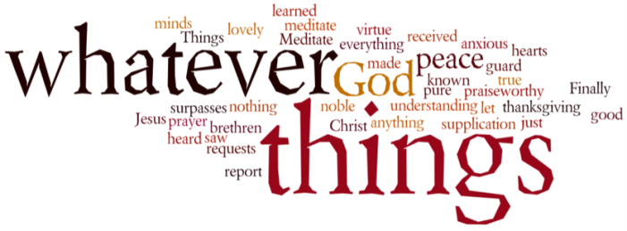
THINK ON THESE THINGS…..
Reading: Matthew 6:25 - 27
²⁵ “Therefore I tell you, do not worry about your life, what you will eat or drink; or about your body, what you will wear. Is not life more than food, and the body more than clothes? ²⁶ Look at the birds of the air; they do not sow or reap or store away in barns, and yet your heavenly Father feeds them. Are you not much more valuable than they? ²⁷ Can any one of you by worrying add a single hour to your life?
Reflection: Have you noticed how much more wildlife is making an appearance around our neighbourhoods these days? Early morning birdsong is the order of the day, starting earlier and earlier each morning, often drowned out by the cacophony of the Swindon seagulls on the roof of Emmanuel. When we go for our daily walk these days we are also often met by a fox, who instead of scuttling away, stares us out as if to say “You’re trespassing on my turf – get lost!” The air seems cleaner, fresher, the grass greener and the flowers brighter in colour and variety. Midst the struggle of isolation, if we are lucky enough to get outside for a while, God is revealing himself in some truly amazing ways.
In 1373, a woman aged ‘30 and a half’ was gravely ill. She and her family thought
she was dying. But on 8th May she had a series of visions, which she referred to as
her ‘shewings’, and which later became known as the Revelations of Divine Love. She
started living in a cell attached to a church in Norwich from where she gave spiritual direction and lived a life of prayer. Julian’s near-death experience made
her value the wonder and joy in each moment and the gift of life that God gives us.

‘And in this Christ showed me a little thing the size of a hazelnut lying in the palm
of my hand and it was as round as any ball. I looked there upon it with the eye of my
understanding, and I thought: what may this be? And I was answered thus: it is all
that is made. I marvelled how it might last, for I thought it might disintegrate to
nothingness. And I was answered: it lasts and ever shall because God loves it, as have
all things that have their being by the love of God. In this little thing I saw three properties:

The first is that God made it, the second is that God loves it and the third is
that God keeps it. When I behold the Maker, the Lover and the Keeper I know that I
won’t see true bliss unless I fully unite with God and rest in Him, with nought
between us. That the knowledge I need is that God loves us and we should have love
for God.’

Breath-Prayer for Today:
May the God who holds us tenderly in the palm of His hand, comfort us.
May the God who feeds us tenderly, direct us.
May the God who loves us tenderly, bless us,
Creator, Redeemer and Sustainer. Amen

