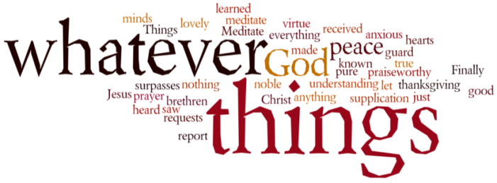
THINK ON THESE THINGS…..
Reading: Psalm 121: 5 - 8
⁵ The Lord watches over you –
the Lord is your shade at your right hand;
⁶ the sun will not harm you by day,
nor the moon by night.
⁷ The Lord will keep you from all harm –
he will watch over your life;
⁸ the Lord will watch over your coming and going
Both now and for evermore.
Reflection:
Yesterday afternoon I conducted the funeral service for Alan at Kingsdown crematorium. It was never going to be an easy occasion with Mary and the family having to face the restrictions on numbers attending, and having to sit apart from each other. Nevertheless, it was an opportunity to reflect, to remember and celebrate Alan’s life.
I wanted to share with you a few verses from one of the readings I chose, as I believe it gives us such assurance and comfort when we have to say goodbye to a loved one. However, the image of our Lord watching over us during the times we are all going through right now, also gives so much assurance and comfort to me.
In those moments when it all gets just too much to cope with; in those moments when you feel like crying out “When will this all be over?” In those moments when we feel bereft of God’s presence, remember these words – “God is watching over my life right now, and forever.” He is watching not “from a distance” in the words of the Bette Midler song, but is with us always through the presence and motivation of his Holy Spirit, and that presence is a lot closer than we can ever imagine!
Breath-Prayer for Today: Father thank you that for watching over my life, and the lives of your people, always and forever.

