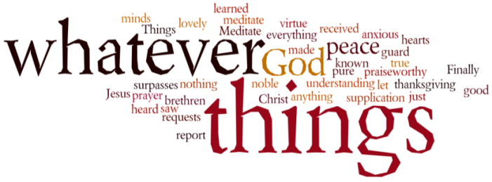
THINK ON THESE THINGS….. FAMOUS LAST WORDS
Reading: Luke 23: 39 – 43
³⁹ One of the criminals hanging there hurled insults at him: “Aren't you the Messiah? Save yourself and us!” ⁴⁰ The other one, however, rebuked him, saying, “Don't you fear God? You received the same sentence he did. ⁴¹ Ours, however, is only right, because we are getting what we deserve for what we did; but he has done no wrong.” ⁴² And he said to Jesus, “Remember me, Jesus, when you come as King!” ⁴³ Jesus said to him, “I promise you that today you will be in Paradise with me.
Reflection:
In the weeks running up to Easter, high up on a mountainside called Platterkloof just outside the Cape Town city bowl, a cross used to appear. It was visible for miles, particularly at night when it was lit up. It was a reminder to all that something different was happening at this time of the year.
I often used to think when driving by “Why did they content themselves just with the one cross, and not include the other two as well?” One cross makes a crucifix – three crosses make a church. All the gospels mention that Jesus didn’t die alone, but only Luke refers to the conversation Jesus held with the two on either side of him. The one joined in with the crowd sneering, “If you are the Messiah, get us out of this mess.” The other defended Jesus, suggesting he had done nothing wrong, whilst they were getting what they deserved.
These two on either side of our Lord displayed contrasting attitudes to God and faith that we come across today. The one probably showed an attitude of bitterness throughout his life, an unwillingness to take responsibility for his actions. It was the judge’s fault, the jury’s fault, God’s fault. It was the fault of the man hanging beside him.
The other seemed to know exactly what he had done to end up in this position. He had a sense of justice, and was willing to own up to his part in the verdict. Who knows what allowed him to do that. Maybe he was one of those criminals who was half relieved to get caught, or maybe he was someone who was a bit of a gambler with a conscience!
While the one hung on the cross cursing all and sundry, the other turned to face his death and even opened his arms to it. “Jesus, remember me...” were his words. That’s all he asked, but he was given a great deal more – “Today you will be with me in paradise” said Jesus.
Three crosses – the one in the middle bridging the distance between them, the bitter man and the hopeful one, the lost one and the found.
We only have one cross at the front of the church at Emmanuel, but God knows we are hanging on the other two. Whenever we stand near his cross, we complete the tableau. One cross makes a crucifix. Three crosses make a church.
Breath-Prayer for Today: Lord Jesus, we take comfort in the meaning of your cross in our lives. You died for us, and for everyone – the cynical and the struggling, the hopeful and the faithful.

