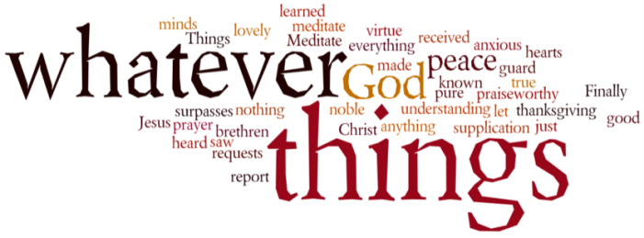
THINK ON THESE THINGS…..
Reading: Song of Solomon 2:1
‘I am the rose of Sharon, and the lily of the valleys.”
Reflection:
Probably one of the least read books in the Old Testament is the Song of Songs, yet in these few short chapters comes this verse

“I am the rose of Sharon, and the lily of the valleys.” Sharon is the central section of the Coastal Plain of Israel. The Plain lies between the Mediterranean Sea to the west and the Samarian Hills, about 9 miles to the east.

According to the OT chronicler, Sharon was a place of pasture, a place of feeding, where the flocks used to rest, a fruitful valley where wild flowers grew in great abundance.

It was probably a place where families could gather to share a picnic, to take in the views and the scent of the beautiful flowers.

Sue reflected in her devotion yesterday that the situation we are facing has forced us to stop and reflect on our lives. Being in lockdown has made us appreciate the creation around us so much more, taking time to “smell the roses”, taking time to appreciate God’s love and goodness toward us.

All of you have been making sure you use the time to be an encouragement to others by making phone calls or sending messages – thank you for doing that!

We will probably never experience anything quite like this in our lifetimes again. Use this time to revel in God’s love for you, a love made manifest in so many special ways.
Breath-Prayer for Today:
Lord Jesus, today I thank you once again for your love for me, made clear in some of those things that often used to pass me by.

