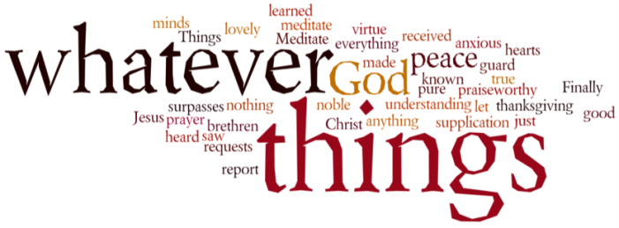
THINK ON THESE THINGS….. (our contributor this morning is Brian Eyles)
Reading: Jeremiah 4: 23,26,27
I looked at the earth - it was barren waste: at the sky – there was no light.......
The fertile land had become a desert, its cities were in ruins because of the Lord's fierce anger. ( The Lord has said that the whole earth will become a wilderness, but that he will not completely destroy it)
Reflection:
Long before Jesus ancient prophets put the fear of God into believers. There were fewer places more fearful than the The Wilderness. Moses had led his people where there were snakes, scorpions, and no water and almost no food. They were so full of their fears they wanted to go back to slavery in Egypt.
But Jesus brought us out of religion motivated by fear. One of his few direct commandments was 'Don't be afraid'. But you may ask, wasn't Jesus afraid in the Garden of Gethsemane? Yes, he was only human, but he put his fear to one side and in front of it he placed his obedience; his acceptance of his Father's will. He prayed 'Nevertheless.....your will be done'.
So if this wilderness of the Pandemic threatens to fill you full of fears, or worry and apprehension, by the power of the Holy Spirit, let them be put to one side so that submission to the will of Our Father comes first.
Breath-Prayer for Today:
Gracious Father, bless us with the gift of the Holy Spirit, that day by day we shall have the strength to make your will the priority that puts all our fears to one side.

