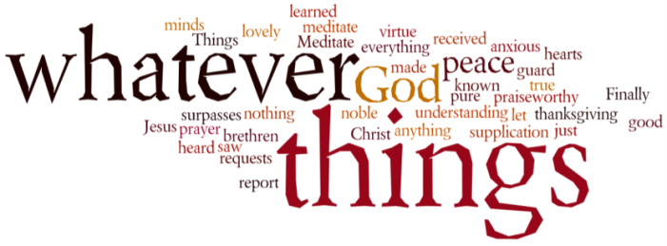
THINK ON THESE THINGS….. (our contributor this morning is Sue Martin)
Reading: Ecclesiastes 3: 1 – 8 “A time for everything”
There is a time for everything,
and a season for every activity under the heavens:

Everything that happens in this world happens at the time God chooses.
Reflection:
The Ecclesiastes reading will be well known to you, and I know it is a particular favourite of some church family members. The reading states that there is a time for everything and gives a list of these such as a “Time for birth and a time for death”.

During the past weeks we have learnt there is also a “Time to stop”, “A Time to Adapt” and a “Time to Wait”.

“A time to stop” - This time of stopping has given us all a chance to have a break from the business of our lives and in some cases (including myself) has given us a welcome break.

“A time to adapt” - We have had, to adapt to isolation and I know that some of you have coped with this much better than you thought you possibly would, while others have struggled. People have had to adapt to a different work regime – working from home, being furloughed and some still attending their place of work but with strange routines. Children have had to adapt to not attending school and parents to home tutoring the.

“A time to wait” – We are all waiting to move out of this crisis situation and in to a normal life. We will have to wait to see what format that life will have and what long term changes the virus will have made.

However, despite all the difficulties we have experienced, there is always time in our lives for our faith, our love of God and our love for each other.
Breath-Prayer for Today:
Dear Lord. Be with us in this time of turmoil in our lives. Give us patience to wait for the right time to move away from the current situation and look to the future. Amen

