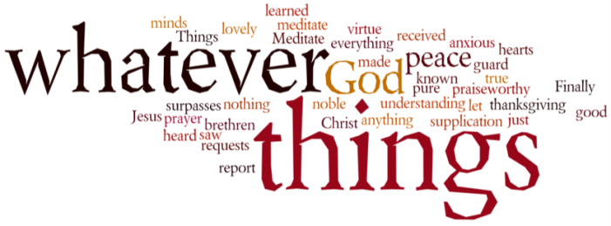
THINK ON THESE THINGS…..
Reading: Joel 2: 25 - 26
²⁵ ‘I will repay you for the years the locusts have eaten –
the great locust and the young locust,
the other locusts and the locust swarm –
my great army that I sent among you.
²⁶ You will have plenty to eat, until you are full,
and you will praise the name of the Lord your God,
who has worked wonders for you;
never again will my people be shamed.
Reflection: This reading from Joel is part of the prophecy that Peter quoted in his sermon on the day of Pentecost. While we know almost nothing of the prophet Joel, or when his prophecy was written, we do know that it refers to a time of great trauma – a plague of locusts – in the life of God’s people. Whether these were literal insects, or a metaphor for a great army is uncertain, but the devastation that was left in their wake is clear.
As we approach a time where restrictions on lockdown appear to be easing, we can identify a little with the trauma that the people of Israel were going through. It certainly hasn’t been an easy or comfortable road for any of us to travel. Yet we have the promise of the Lord to meet the people in their grief and to restore them.
Joel offers a vision of a time of abundance and peace that will come, but then he goes even further. He speaks of God’s Spirit being poured out on the whole earth, and filling every person, from the least to the greatest. This was a miraculous dream for the devastated people of God, and it offered a restoration that included bringing their whole being into union with their Lord.
As we reflect on the gift of the Spirit this week, I believe this vision offers us great hope and encouragement. Whatever brokenness we experience in our world and in our lives as a result of Covid 19, whatever our particular “locusts” have destroyed, God’s Spirit comes to restore and heal us and bring us back into union with God.
Breath-Prayer for Today: Speak to me, Lord God, empower me with your Spirit, and fill my heart with a new vision of your reign fully revealed in the world.

