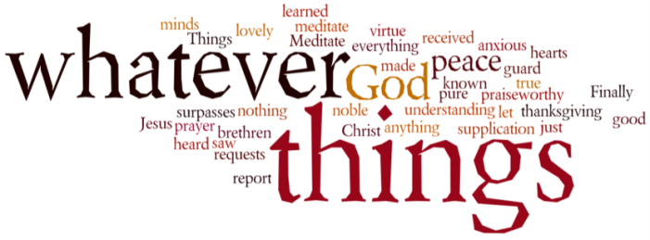
THINK ON THESE THINGS….. (our contributor this morning is Tony Wilson)
Reading: 2 Corinthians 13:13
The grace of our Lord Jesus Christ, the love of God, and the fellowship of the Holy Spirit be
with you all.

Reflection:
Some of you know that I've been a Dr. Who fan since its first episode in 1963. Whenever the actor who plays Dr. Who wants to leave and move on, the Doctor 'regenerates' and the audience have to get used to a new actor playing the role. Each actor does this differently, but has the same underlying goodness.

In 1973, to mark the programme's tenth anniversary, a special story, 'The three Doctors', was broadcast in which all three actor, who'd by then played the Doctor, appeared together. Patrick Troughton, who played the second Doctor, when later interviewed about this story, said: 'We are all different aspects of the same character'. He also described it as 'a bit of a mystery'. When I read this interview recently I thought: 'What a wonderful illustration of the Trinity'.

We've now reached the time in the Christian year when, a week after Pentecost, Trinity Sunday comes along. From the Middle Ages onwards this Sunday has been observed as a feast honouring the Trinity. It marks the conclusion of the part of each year which Christians set aside to remember the life of Jesus. However, many Christians find the Trinity a mystery which is hard to understand.

Three in One and One in Three sounds like very strange arithmetic. The word 'Trinity' isn't even mentioned once in the Bible. It only began to be used towards the end of the second century. By then Christians, who were very clear that there was just one God, also realized that God bad been revealed to them in three different ways.

The first was as Father, the Creator who bad made everything, and was the ground of their being. The second way was as Jesus the Son of God. By taking on a human form and living and suffering among humanity, people found it was much easier to relate to this aspect of God. The third way was as Holy Spirit, a source of power, wisdom and inspiration in the lives of Christians, at a time when, after the Ascension, Jesus' physical presence bad been withdrawn from them. I firmly believe that at the present time with a world in crisis, this third aspect of the Trinity, the Holy Spirit, is very important to guide us and our leaders.

Just as in my Dr. Who example at the start of this reflection we saw three different aspects of the same character, so in the Trinity we see three different aspects of the one God.

Breath-Prayer for Today: Almighty God, who revealed yourself to us as Father, Son and Holy Spirit, help us firmly to believe in you in all your ways, who are three persons yet one God, for ever and ever. Amen.

