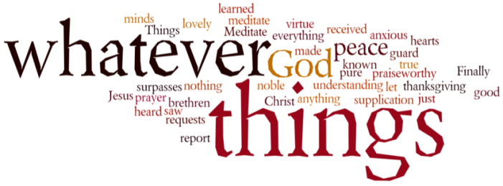
THINK ON THESE THINGS…..
Isaiah 40:1,2

Comfort, comfort my people,
says your God.
² Speak tenderly to Jerusalem,
and proclaim to her
that her hard service has been completed,
that her sin has been paid for,
that she has received from the Lord’s hand
double for all her sins.
Just over a week ago if I’d have asked how many folk used social media like Whatsapp, Messenger, Zoom or Lifesize, you may well have been one of those who thought I might be talking about new trendy clothing brands for millennials! How quickly things have changed.
Every day I hear stories of how these forms of communication are providing a lifeline for families and friends all across the world. Folk across the age spectrums are embracing these new forms of technology with open arms, as for the very first time some are able not only to hear their loved ones and friends on the other end of the line, they are actually able to see them as well.
Friendships are either being newly forged, and old connections rekindled, and midst the turmoil and general unease of these times, we are discovering so much more about our families, friends and neighbours. I was speaking to a colleague of mine yesterday who shared her story of a relationship that had gone sour over the past months, suddenly changed in a matter of days. We are talking and sharing our concerns and worries with one another, and drawing comfort from the fact that we actually need each other now more than ever before!
“Comfort, comfort my people….speak tenderly” – these are words you are all taking seriously, and as your minister I want to say thank you for all that you are doing in sharing in whatever way you can, the comfort and loving presence of our Lord with those around you.
Breath-Prayer for Today: Father God, you have promised to bring comfort in our time of need. As you bring comfort to us, help us to share comforting and tender words to those who are feeling vulnerable and in need of assurance at this time.

