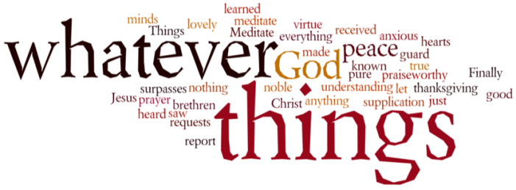
THINK ON THESE THINGS…..
Reading: Reading: Judges 6:36-40
³⁶ Gideon said to God, “If you will save Israel by my hand as you have promised—³⁷ look, I will place a wool fleece on the threshing floor. If there is dew only on the fleece and all the ground is dry, then I will know that you will save Israel by my hand, as you said.” ³⁸ And that is what happened. Gideon rose early the next day; he squeezed the fleece and wrung out the dew—a bowlful of water.
³⁹ Then Gideon said to God, “Do not be angry with me. Let me make just one more request. Allow me one more test with the fleece, but this time make the fleece dry and let the ground be covered with dew.” ⁴⁰ That night God did so. Only the fleece was dry; all the ground was covered with dew.
Reflection: Gideon was an unimportant young man, from an insignificant family and clan, yet God had called him to rescue His people. Feeling rather uncertain of himself, Gideon asked God to prove that God had called him. And so he came up with the idea of placing a fleece on the ground and testing whether dew could fall on the fleece and not on the ground, and vice versa. According to the story, God honoured his request and gave him the proof he needed. Gideon’s questions were not wrong. He simply needed to be sure that he had heard God correctly.
Gideon asked for assurances to overcome his doubts, and he received what he had asked for. This can be both a comfort and a caution to us. The comfort comes because we do not have to be ashamed of our need for reassurance. Perhaps now more than ever before do all of us need the assurance that in our relative solitude, God is still with us.
But, the caution is that we cannot always expect that we will receive the kind of assurances we desire. Sometimes God speaks in unexpected ways, and sometimes God does not seem to speak at all. Despite this apparent silence, we need to make the choice to remain faithful even in the midst of our doubts. When we can do this, we know that we are maturing in faith, and our need for signs grows less. Yet, surprisingly, as we trust in the midst of doubt, we become a sign that strengthens the faith of others.
It is really difficult to look for signs that God is with us right now. There are going to be times when we feel really low and in need of a bit of a lift. And then comes that phone call, the one that you either receive or make, and God is right there in the midst of those moments.
When we pray, we affirm our faith in God’s care and God’s ways. We know that the answers we receive may be unexpected, surprising or very different from what we desire, but we continue to pray anyway, because we need this discipline. Today, offer your prayers for yourself and others in faith and trust that, whatever the answer, God is working in and through you.
Breath-Prayer for Today: I offer you my prayers, O God, trusting in your grace and compassion.

