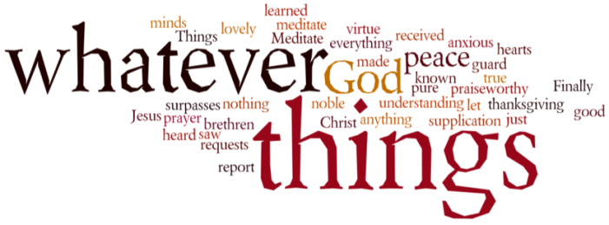
THINK ON THESE THINGS…..
Reading: Psalm 34:1 – 3
I will always thank the Lord;
I will never stop praising him.
² I will praise him for what he has done;
may all who are oppressed listen and be glad!
³ Proclaim with me the Lord's greatness;
let us praise his name together!
Reflection:
75 years ago today, the streets of our land were filled with tens of thousands of people celebrating the end of hostilities as World War 2 came to a close. The euphoria of the moment was overshadowed by the huge loss of life experienced by Britain and the allied forces over the 6 or so years of conflict.
As we know, plans had been arranged for celebrations to take place throughout the land today. We were due to be joining together with fellow Haydon Wick residents at the King George fields, and many had been planning street parties up and down the land.
Sadly all of these had to be cancelled due to the outbreak of Covid-19, and any planned celebration will have to take place either indoors or in our back gardens!
But celebrate we will, for even midst these strange circumstances there is always time to give thanks to the Lord for his goodness and presence in our lives, for the many wonderful ways he has encouraged us through the support of family and friends, as well as through our church family.
Times will remain difficult, frustration levels will wax and wane, but we’ve in this together – you and I and God!
Breath-Prayer for Today:
Lord God our Father,
we pledge ourselves to serve you and all humankind, in the cause of peace,
for the relief of want and suffering,
and for the praise of your name.
Guide us by your Spirit;
give us wisdom;
give us courage;
give us hope;
and keep us faithful now and always.
Amen.

