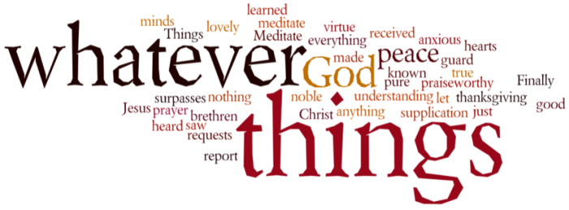
THINK ON THESE THINGS….. FAMOUS LAST WORDS
Reading: Luke 23: 32 – 34
³² Two other men, both of them criminals, were also led out to be put to death with Jesus. ³³ When they came to the place called “The Skull,” they crucified Jesus there, and the two criminals, one on his right and the other on his left. ³⁴ Jesus said, “Forgive them, Father! They don't know what they are doing.”
Reflection:
Luke’s version of Jesus’ death is very different from the other gospels. Luke puts the focus on human beings forsaking the Lord….not the Father. Not all humans, just some of them, but those few made their voices heard very clearly. The charges were straight forward – blasphemy was the church’s case against him, and treason was that of the state, because he allowed his followers to call him their king. Both church and state were scared of him because he was stirring up the people, and they were probably right in their assessment.
But no-one wanted to take full responsibility. From Caiaphas, through to Pilate, they were both just doing their job, stuck between a rock and a hard place. If they made the wrong move, it may well have resulted in a people’s revolt. They both had nothing personal against Jesus, but quickly realised that if they removed the trouble-maker, things should settle down. Hands were washed, the die was cast, and Jesus was on his way to Golgotha.
The author Dorothy Sayers once said, “They did away with God in the name of peace and quietness.” They did away with him in the name of law and order, and in the defence of scripture and their beliefs. These were the things that Jesus challenged throughout his ministry, and it was these things that got him killed.
He was eliminated by piety and due process, but not before he forgave them both. Before his death, he uttered those words, “Father, forgive them, they don’t know what they are doing.” I guess the bystanders might have thought it strange to hear a condemned man forgiving others – could he have been referring to the Romans, the Jews, the disciples, the soldiers, Caiaphas, Judas, Pilate or perhaps the thieves on either side of him? Who knows?
The important word though was “forgive.” It meant that he didn’t want anyone punished for his death, especially people who didn’t really have a clue about what they were doing. Amazing isn’t it, that while they pronounced him guilty, he maintained their innocence.
By the time they had nailed him to the cross, there was not much more he could do to show them that there was another way. But what he could do, he did. As he stretched out his arms he forgave them, and he forgives us in exactly the same way today. At the foot of the cross – this is where we find out what love is all about. This is where we find forgiveness.
Breath-Prayer for Today: Lord Jesus, you went to your death in the name of peace and quietness. Yet in the midst of your pain and suffering you reached out in love then, and still you reach out to us with your love and forgiveness today.

