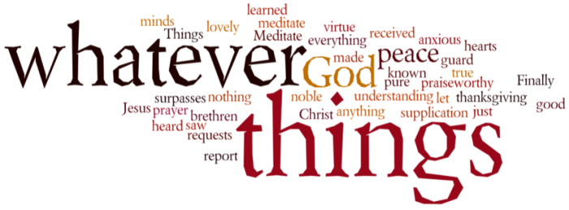
THINK ON THESE THINGS…..
Reading: Isaiah 26:1 - 4
In that day this song will be sung in the land of Judah:
We have a strong city;
God makes salvation
its walls and ramparts.
² Open the gates
that the righteous nation may enter,
the nation that keeps faith.
³ You will keep in perfect peace
those whose minds are steadfast,
because they trust in you.
⁴ Trust in the Lord forever,
for the Lord, the Lord himself, is the Rock eternal.
Reflection: After a devastating vision of judgement on the whole earth, the prophet Isaiah began to speak about God’s salvation and restoration. He envisioned God spreading a feast for all the earth’s people on God’s Holy Mountain, and then he proclaimed that death would be swallowed up and removed from the earth. Today’s short reading is the response to these events which the prophet saw God’s people would express. The heart of the song is a statement of trust in God.
God is the one who surrounds the dwelling place of His people and makes their city strong. God is the one who brings peace to those who trust in Him. God encourages us therefore, to trust in Him as our eternal Rock - a sure foundation on which to build our lives.
The resurrection reminds us that death does not have the final word, and that God surrounds us with life and strength. When we learn to trust in God’s resurrection life, God keeps us in peace, and our thinking and living is shaped by God’s unquenchable life.
If we live with cynicism and negativity, this is probably a sign that we have not yet truly believed in resurrection. But, as the reality of resurrection takes hold of us we inevitably grow in trust and in hope.
When the reality of resurrection life begins to take hold of us, we cannot help but respond in thanksgiving. But, giving thanks also strengthens our faith in resurrection even more, as we remember the ways that God’s life has already sustained and strengthened us. Today let the practice of thanksgiving strengthen your faith and inspire your hope.
Breath-Prayer for Today: Thank you, God, for your gift of life that cannot be quenched.

