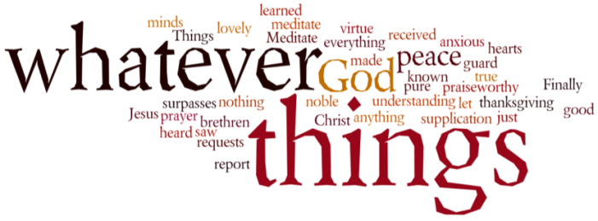
THINK ON THESE THINGS…..
Reading: 1 Timothy 4:7b - 9
Keep yourself in training for a godly life. ⁸ Physical exercise has some value, but spiritual exercise is valuable in every way, because it promises life both for the present and for the future. ⁹ This is a true saying, to be completely accepted and believed.

Reflection:
“Sweet Charity” is a musical written by Cy Coleman and played on Broadway from 1966 onwards. It was also produced for London’s West End theatre and also ran for several years. One of the catchy tunes in the production is called “The Rhythm of Life” and has these words as it’s chorus –
To feel the rhythm of life,
To feel the powerful beat,
To feel the tingle in your fingers,
To feel the tingle in your feet.
For all of us this rhythm of life has been disrupted in a way we never thought possible. The normal rhythm of daily life now includes things we never thought we’d have to do before – exercise in the lounge or garden, shopping in queues that though orderly, now take forever! Conversations now taking place at a distance, and people doing everything in their power to avoid one another if they venture out for a walk!
We’ve all had to find a new rhythm haven’t we, and although many might say it’s forced us all to slow down, I must admit I’m beginning to miss the “beat” and the “tingle” of normality.
In his short letter to Timothy, Paul talks about the need for training for a godly life, and to value spiritual exercise alongside physical exercise. So many of you have commented on the value of these Daily Devotions that have become very much a part of your new rhythm, and have been helpful in providing focus and challenge for the day.
Perhaps God is at work in this new normal, and maybe that’s a really good thing. Midst the new challenges that each of us are facing, God is still speaking, gently urging us on to keep in step with his heartbeat, and in so doing to learn more about ourselves and about each other, and to spend just that little more time giving thanks for all He has done and continues to do for us.
Breath-Prayer for Today: Lord Jesus, you modelled an amazing rhythm of life during your time on this earth. Help us to move to the beat of your heart, as we try our best to follow in your ways.

