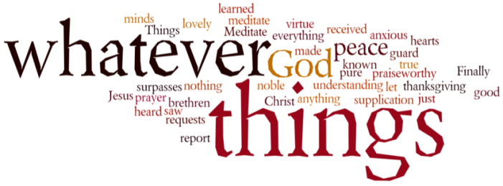
THINK ON THESE THINGS…..
Psalm 137:1 - 4
By the rivers of Babylon we sat and wept
when we remembered Zion.
² There on the poplars
we hung our harps,
³ for there our captors asked us for songs,
our tormentors demanded songs of joy;
they said, “Sing us one of the songs of Zion!”
⁴ How can we sing the songs of the Lord
while in a foreign land?
The imposed isolation we and many families are experiencing in the world right now, has spawned a plethora of very creative individuals, duets and family units, trying their level best to turn the time we suddenly have available to us into something useful, meaningful, and perhaps even memorable. From well know songs now given new life with appropriate lyrics, to comedy clips showing ways to try and get through what can be a very oppressive situation for people.
Years ago the pop group Boney M wrote a song which quickly became a hit all around the world, based on the opening verses of Psalm 137.
https://youtu.be/2FgDles4xq8
It’s a Psalm that talks of the people of God longing for the things of home, the freedom of being able to worship in the temple on Mount Zion. It must have been tough for them being isolated from all the familiar things of home, yet in spite of the taunts and cynicism of their captors, they were able to express their faith by joining together to sing the familiar songs of faith. Being able to maintain their faith in this strange land must have made a big impression on the locals who must have been surprised and challenged by what they saw and heard.
For all of us, this isolation that we are all experiencing is a little bit like living in a strange land. We are discovering everyday how to be church “in a strange land”, and doing a fantastic job in keeping in touch with each other, stepping in to help in whatever way we can, in so doing strengthening our faith in our Lord.
So, let’s keep strong and let’s keep singing the songs of our faith in this challenging time!
Breath-Prayer for Today: Loving God, you never promised an easy life for us if we took on the challenge to walk in Your way. What you did promise is that you would be with us always, so today once again we claim that presence – thank you for your love and ongoing presence.

