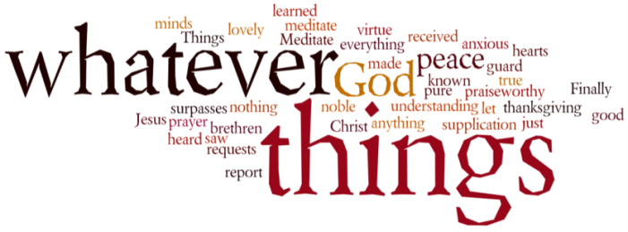
THINK ON THESE THINGS…..
Luke 4: 9 – 13
⁹ The devil led him to Jerusalem and had him stand on the highest point of the temple. “If you are the Son of God,” he said, “throw yourself down from here. ¹⁰ For it is written:
“‘He will command his angels concerning you
to guard you carefully;
¹¹ they will lift you up in their hands,
so that you will not strike your foot against a stone.’^{[d]}”
¹² Jesus answered, “It is said: ‘Do not put the Lord your God to the test.’^{[e]}”
¹³ When the devil had finished all this tempting, he left him until an opportune time.
Those forty days stuck in the wilderness on his own must have been so tough for our Lord. His baptism and commission for ministry spectacular, the Spirit’s blessing now a distant memory as the sandstorms whipped up the tiny particulars that stung every part of his body. Stifling heat during the day, freezing cold at night – could it get any worse? Yes it could…and it did. The tempter knew when to strike, and did so very skilfully. The noose tightened, the isolation grew, and Jesus felt the loneliness like never before.
I think we may all be feeling a little like Jesus felt right now. Everything familiar seems to have been removed from us, and just when we think it can’t get worse, up pops Boris with further instructions wanting to keep us safe.
I am heartened by the way in which Jesus dealt with the pressure. It must have been so tempting to give up, to give in. But he kept his eyes firmly fixed on God. He remembered the stories of faith told to him by his parents, about the time he debated with the scribes and Pharisees in the temple courts, when he stood up in the temple and proclaimed his Fathers word, and that Jordan baptism and blessing. Those memories kept him strong, and enabled him to come through one of the toughest times in his life to that point.
Like Jesus, we are all facing really tough and scary times right now. It’s not going to be easy, and we will no doubt experience highs and lows over the coming days and weeks. The Father never left his Son in the wilderness. The Father, Son and Holy Spirit will never leave us in our moment of need!

Breath-Prayer for Today: Father God, in our moments of vulnerability, stay close to us. Grant us the assurance that you love us so much, and will always be there to carry us through the toughest times.

