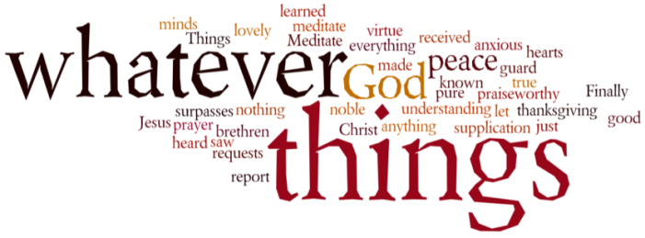
THINK ON THESE THINGS….. (Brian Eyles is our contributor today)
Reading: 2 Corinthians 11:3, 4
St. Paul is worried that the Devil is at work among his friends:
But I am afraid that just as Eve was deceived by the serpent’s cunning, your minds may somehow be led astray from your sincere and pure devotion to Christ. 4 For if someone comes to you and preaches a Jesus other than the Jesus we preached, or if you receive a different spirit from the Spirit you received, or a different gospel from the one you accepted, you put up with it easily enough.
Reflection:
I watched the TV documentary in which Jonathan Dimbleby recalled his father's reporting from the liberated Bergen Belsen camp 75 years ago. I have been haunted by images of death and disease. But also I remember, in the face of present day holocaust deniers, the warning that Richard Dimbleby gave us; history will repeat itself unless we are vigilant.
It seems to me we must beware that voices, opinions and attitudes, especially on social media, can be like a virus infection. It is an infection which corrupts the Christian way of living. Some voices spread hate, not love. Some sow suspicion which has no compassion. Some generate fear in the place of a generous heart.
Just as people have known for 100 years since the Spanish Flu that a pandemic might take hold, so Christians must be aware that moral and spiritual infection will spread like an evil virus in our world if we do not take Christian precautions. Precautions like keeping to Christian Gospel truth, like trusting God in prayer, and believing in the love and compassion of the Holy Spirit.
Breath Prayer: Lord keep us strong by the work of the Holy Spirit: strong to speak the truth, always with love: strong to have hearts and minds filled with the love and generosity of Jesus Christ; and strong to reject all that is fake and full of fear so that we may enjoy the peace and joy of living in Christ

Breath-Prayer for Today: Were the whole realm of nature mine, that were an offering far too small. Love so amazing, so divine. Demands my soul, my life my all.

