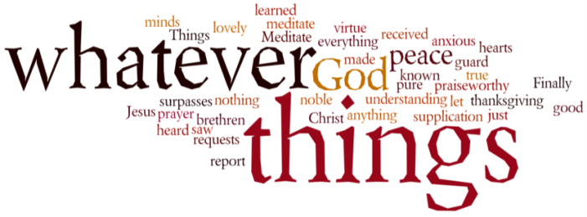
THINK ON THESE THINGS….. FAMOUS LAST WORDS
Reading: Mark 15:33 – 34 / Matthew 27:45 - 46
³³ At noon, darkness came over the whole land until three in the afternoon. ³⁴ And at three in the afternoon Jesus cried out in a loud voice, ‘Eloi, Eloi, lema sabachthani?’ (which means ‘My God, my God, why have you forsaken me?’).
Reflection:
We’ve all past them from time to time, a bunch of flowers laid carefully by the roadside. A sign that something horrible happened here. A life lost in a split second – and then the worst part, the traffic slowing down to see what happened. “How could they?” you say to yourself as the queue of vehicles crawled slowly by the wreckage. Why stop and gawk at tragedy? But its only human – to want to know what has happened, to want to know if someone is hurt.
For most of us it’s because we sense how easily that could have been me. This week we will contemplate the wreck, and we’ve all decided to pull over, to see what happened here. How could things have changed so quickly? Why did such a promising life come to such a bloody end?
The wreckage of the cross is hard for us to understand, which is why each of the gospels tells the story from 4 different perspectives. This week we’ll reflect on words from Mark and Matthew, then from Luke and finally John. The first words are probably the most awful – “My God, why have you forsaken me?”
Right from the beginning of his life, though he may not have understood it, God’s hand was upon him. He had gifts others didn’t have – people wanted to be near him, to listen to his words, to reach out and touch his clothes. Twice he heard those words from heaven telling him who he was – “My Son, my beloved.” Then suddenly, that reassurance from his Father was gone. There was a final prayer in the garden “remove this cup”, but the cup was still there when the prayer was over. Then came the flogging and the words of hatred levelled at him on the cross.
If ever there was a time he needed to be reminded who he was …. But there were no words – just the silence of the God who would say nothing. “Why have you forsaken me?” Why him? Why this? Why the silence? I wish I knew.
All I know is that because of it, none of us ever has to feel what he felt again. When we are feeling at our most hurt, our most frightened, our most forsaken by God, we have this friend who has been there and will always be there for us. “Forsaken” a word which sounds like the end of faith. But maybe it’s just the beginning. In his suffering he is the comfort of those who have no comfort. In his abandonment, he is the God of those who have no God. Those final words were to become the voice of love for the world.
Breath-Prayer for Today: Lord Jesus, in the raw pain of the silence of the Father, those famous last words have become words of consolation and strength in our lives.

