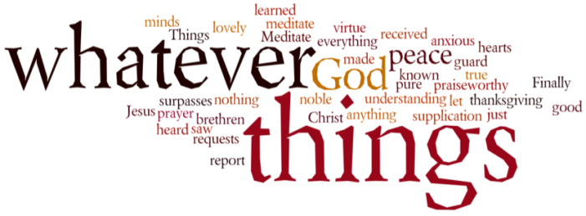
THINK ON THESE THINGS….. (our contributor this morning is Angela Jones)
Reading: 1 Peter 1: 6 - 7
“In this you rejoice, even if now for a little while you have had to suffer various trials, so that the genuineness of your faith – being more precious than gold that, though perishable, is tested by fire – may be found to result in praise and glory and honour when Jesus Christ is revealed”.
Reflection:
A crucible is a piece of equipment that is used in the melting and testing of precious metals. An alternative meaning though is “a situation of severe trials in which different elements interact, leading to the creation of something new”. I wonder if any of us feel as if we are in a crucible being tested by our current coronavirus pandemic. We have had to adapt our whole way of life and find new ways to achieve what we need to do. Peter compares times of trial to the refinement of gold and says that our faith is more precious and that it too can be tested.
While we may not welcome this time of testing it is surely true that we have become more aware and appreciative of the love and service that those around us are giving. Our faith, our love, our sharing with others and accepting and giving help to others is surely producing something new. I believe it has awakened us to a new realisation that we are all an integral part of one human society.
I pray that as Peter says that the refinement of our faith will be found to result in praise, glory and honour to Jesus.
Breath-Prayer for Today: Lord Jesus be with us we pray in this time of the refinement of our faith so that you may be glorified. Amen.

