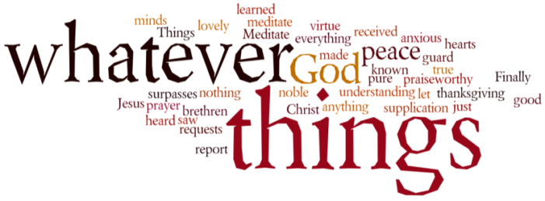
THINK ON THESE THINGS….. (prepared by Brian Eyles)
Jeremiah 37: 14-16
Jeremiah tell his own story, how the city was threatened by both the Egyptian and the Babylonian armies, how he thought it was safe to go and do some family business. But a soldier stopped him at the city gate:
“You are deserting to the Babylonians”. I answered, “That's not so! I'm not deserting”. But Irijah would not listen to me. Instead, he arrested me and took me to the officials. They were furious with me and ordered me to be beaten and locked up in the house of Jonathan, the court secretary, whose house had been made into a prison. I was put in an underground cell and kept there a long time.

Most of us are feeling trapped, one way or another, and some would say imprisoned in our own homes. Let's remember, though, that scripture tell us the people of God, from Joseph to St. Paul, were imprisoned. We may feel confined, lonely, fearful, and helpless, but so did people of faith like Jeremiah. He lived in uncertain times.
He had to obey the authorities. He saw homes being turned into prisons. He was scared he might die in Jonathan's house. But more important than all these feelings was the conviction that the Lord was with him. Just like Joseph, John the Baptist, St. Paul, and Jesus in spite of confinement each had a message to deliver, or a mission to pursue, or a task to accomplish. If being trapped feels like the loneliness of a prison cell it can also be a monastic cell where being solitary is an opportunity for praying like we have never prayed before.

Breath-Prayer for Today: Lord Jesus Christ, the friend and carer of all our souls, take away our fears and bless us in our solitariness. Grant us compassion for the needs of family, friends, neighbours, and the whole endangered global community

