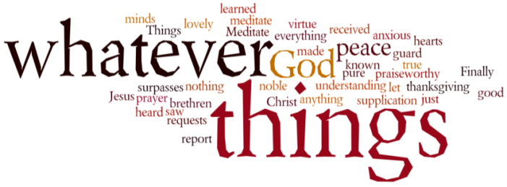
THINK ON THESE THINGS…..
Reading: John 21:1 - 4
Afterward Jesus appeared again to his disciples, by the Sea of Galilee.^{[a]} It happened this way: ² Simon Peter, Thomas (also known as Didymus^{[b]}), Nathanael from Cana in Galilee, the sons of Zebedee, and two other disciples were together. ³ “I’m going out to fish,” Simon Peter told them, and they said, “We’ll go with you.” So they went out and got into the boat, but that night they caught nothing. ⁴ Early in the morning, Jesus stood on the shore, but the disciples did not realize that it was Jesus.
Reflection:
It does seem a little weird that despite seeing Jesus twice in his risen state that Peter should return to his old occupation of fishing. Perhaps this was because he still expected Jesus to reject him for his denial. Or maybe it was because the reality of the resurrection had not fully sunk in.
Whatever the case, the scenario that John describes in today’s reading is almost exactly the same as the one that Luke tells about at the first call of Peter (Luke 5:1-11). We can’t know if John was deliberately trying to connect Jesus’ reinstatement of Peter with Jesus’ first call, but we do know that the large, unexpected catch of fish was symbolic of what Jesus wanted Peter to do as a disciple who was walking the way.
Another surprising feature of today’s reading is that, even after the great catch of fish, it wasn’t Peter who recognised Jesus, but “the disciple whom Jesus loved”. It is likely that John was giving us an insight into Peter’s state of mind. He was clearly still wrestling with the guilt of his failure - as is revealed in the conversation with Jesus that follows today’s reading. In his grief and regret Peter had closed his heart and mind. He was blinded to Jesus’ presence, and to the possibility of forgiveness.
He had slipped back into old ways, and allowed himself no sense of hope or possibility.
We know the feeling don’t we? Before the pandemic things were going so well. Life was normal. Now we are having to live with the “new normal”, and the longer it drags on, the harder it is to retain that sense of hope and possibility.
Midst Peter’s despair, Jesus appeared and restored him. It’s good to know that there is nothing we can do or have to go through that places us beyond the reach of Jesus’ grace and life. What we need to be careful of is not to allow our state of mind to shut our hearts to the extent that we become unable to recognise Jesus when he reaches out to us.
We are all going to have good days and bad days during these times. This is normal. There will be times where God’s presence will seem a distant reality. But God is closer than you think – in birdsong, refreshing rain, a cheery voice on the phone. In these things and more, God is there!
Breath-Prayer for Today: Forgive me, Lord when I I find it difficult to trust in your presence. Stay close to me, especially when I find it hard to stay close to you.

