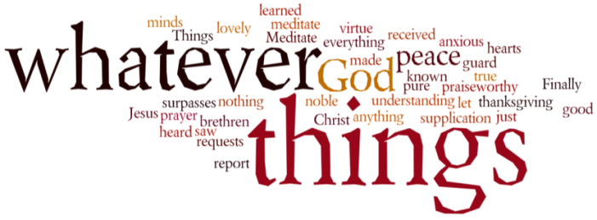
THINK ON THESE THINGS…..
Reading: Proverbs 3:13 -18
¹³ Blessed are those who find wisdom,
those who gain understanding,
¹⁴ for she is more profitable than silver
and yields better returns than gold.
¹⁵ She is more precious than rubies;
nothing you desire can compare with her.
¹⁶ Long life is in her right hand;
in her left hand are riches and honour.
¹⁷ Her ways are pleasant ways,
and all her paths are peace.
¹⁸ She is a tree of life to those who take hold of her;
those who hold her fast will be blessed.
Reflection:
Following on from yesterday’s call to trust in God’s ways, the writer of Proverbs now calls us to seek wisdom. In the book of Proverbs, wisdom is associated with God. It is a source of life and a description of just who God is. These few verses of Proverbs describe wisdom as the most valuable and desirable thing we can seek. It is better than precious metals and stones. It guides us down paths that lead us to joy and delight. It offers us life and brings great satisfaction. It is a “tree of life” that should be clung to.
Sadly though there are many other “wisdoms” in our world that we soon discover aren’t very wise at all. The sort of wisdom to which I am referring often focusses on the self, and everything that the individual is able to accomplish.
However, the wisdom that the writer of Proverbs describes is very different from this. It is expressed in care for and service of others. It is rooted in love for God and our neighbour, and emphasises the disciplines of simplicity, service and sacrifice that Jesus proclaimed. This is true wisdom and it is indeed a tree of life, if we have the courage to embrace and cling to it.
Today’s reading is a song of praise in which wisdom is celebrated and honoured. When we praise something like this, we must try and do everything to focus our minds and energies on it. This is why praise is such a powerful and important discipline - it captures our hearts with the desire for God’s ways.
Breath-Prayer for Today: Loving God, I praise your wisdom, for it is more valuable than riches, and it leads me to life.

