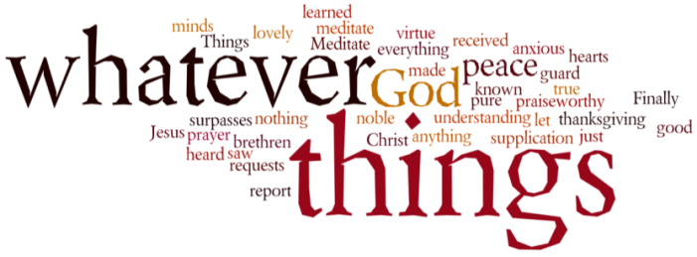
THINK ON THESE THINGS….. FAMOUS LAST WORDS
Reading: John 19:29 – 30
²⁹ A bowl was there, full of cheap wine; so a sponge was soaked in the wine, put on a stalk of hyssop, and lifted up to his lips. ³⁰ Jesus drank the wine and said, “It is finished!” Then he bowed his head and gave up his spirit.
Reflection:
One of the greatest challenges in counselling is the ability to get someone to open up and share their feelings. There are many techniques that can be used, but I guess one of the most straight-forward is simply to say, “Tell me about it.” The response may well be “Tell me about what?” That’s the point – both counsellor and client don’t know yet, but the “it” will soon become clear as the conversation proceeds.
“It is finished”, said Jesus. But what was Jesus referring to here? For one it was the process of dying which must have been excruciating. The other that that was finished was the project he had begun just three years before. Ultimately though, the teaching, miracles, preaching or prayer just wouldn’t cut the mustard.
If he was going to get his message through, something else was required. The night before his death he said this, “Great love has no-one than to lay down one’s life for one’s friends.” Having explained it to his friends, he then left the room to go and do it. Less than 24 hours later, it was finished.
There was one more thing that was finished that day, and that was the separation between himself and the Father. According to John, the distance was mostly physical, and definitely only temporary. The moment he breathed his last he went to be with God. What was left behind was just a body. Those who stood at the foot of the cross and looked upon a scene in which God had died because he loved them so much.
He had shown them a dangerous way to live. It was finished. His part was over. The Sabbath came and went. There was more to come.
Breath-Prayer for Today: Were the whole realm of nature mine, that were an offering far too small. Love so amazing, so divine. Demands my soul, my life my all.

