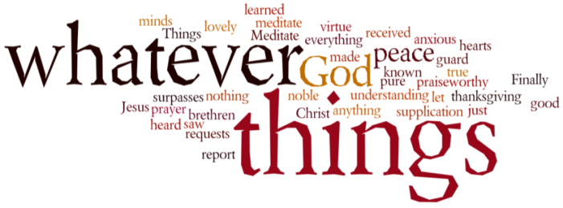
THINK ON THESE THINGS…..
Reading: Acts 1:10,11
¹⁰ They were looking intently up into the sky as he was going, when suddenly two men dressed in white stood beside them. ¹¹ “Men of Galilee,” they said, “why do you stand here looking into the sky? This same Jesus, who has been taken from you into heaven, will come back in the same way you have seen him go into heaven.”

Reflection:
Today is Ascension Day, one of the days that doesn’t seem to attract much attention on the church liturgical calendar. The story of Jesus leaving us has sometimes caused confusion, not least over the issue of the location of heaven. Luke was certainly not trying to offer proof that heaven is “up above” and that God is watching us “from a distance”. His purpose was not to give scientific explanations, but to explain truths about Jesus. As we mark the Ascension today, we do well to keep these truths in mind.
To begin with, the Ascension reveals that, unlike Lazarus, Jesus did not die again after his resurrection. The new life Jesus revealed is eternal, and it fills the entire universe. But, the Ascension also described Jesus as returning to God’s presence in the flesh. This means that Jesus took our full humanity – body, soul and spirit – with him into God’s presence and being. In the Ascended Christ, humanity and God are completely and eternally united, and even our bodies are part of God’s life.
Finally, the Ascension prepared the way for Pentecost which teaches that God has come to fill us with His Spirit. So, not only has Jesus carried our humanity into the Godhead, he has also enabled the Godhead to come into us! This is hard to understand, but I encourage you to think about it through today.
As we remember everything that Jesus has done for us and made possible for us, we can only respond in praise. Sometimes we praise God for things we barely understand, but as we express our awe, our hearts begin to grasp what our minds cannot. Today, we praise Jesus as the Ascended One, and we allow our hearts to be filled with this amazing truth, even if our minds struggle to understand.
Breath-Prayer for Today: Risen and Ascended Jesus, I praise you for making me one with God and for filing me with your eternal life.

