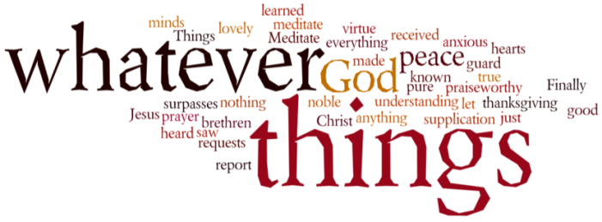
THINK ON THESE THINGS….. FAMOUS LAST WORDS
Reading: John 19:28 - 29
²⁸ Jesus knew that by now everything had been completed; and in order to make the scripture come true, he said, “I am thirsty.” ²⁹ A bowl was there, full of cheap wine; so a sponge was soaked in the wine, put on a stalk of hyssop, and lifted up to his lips.
Reflection:
By the time we get to this statement of our Lord he has already had to go through excruciating pain and suffering. So, it does seem a little strange to hear him say “I am thirsty” at this point. However, there is a very clear reason for this. John loves signs. In his gospel nothing is simply what it seems. Bread is never just plain bread – it is manna from heaven. Wine is not just plain wine – it is the wine of God’s presence. Water is not just plain water – it is living water, going right back to the very beginning of creation.
For John, everything that has happened, has happened for a reason. In other words what is happening to Jesus now could be seen as the last act in a very long drama. Having accepted punishment for the sin of being human, he is now suffering the consequences of that sin. He has given away everything, drained, dehydrated just like a large reservoir that has been opened up to save the surrounding land from drought. What an amazing price to pay. His sacrifice is made all the more clear in words we sing from the hymn - When I survey – “love so amazing, so divine…”
So what is he thirsty for? Surely not the cheap wine he was offered at the end of a stick? No – he was thirsty for heaven. Thirsty for a reunion with God, there was only one way he knew how to get there. “I am thirsty” were his words. What he actually meant was, “I am ready for heaven.”

Breath-Prayer for Today: Lord Jesus, as I witness your suffering, help me to thirst for the life that you have called me to live each and every day of this life on earth.

