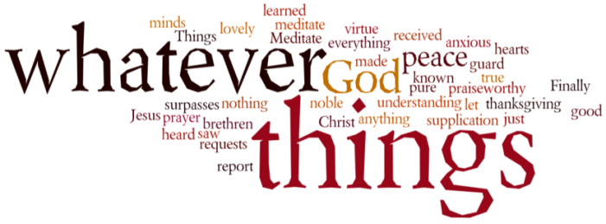
THINK ON THESE THINGS…..
Daniel 1:18 - 20
¹⁸ At the end of the time set by the king to bring them into his service, the chief official presented them to Nebuchadnezzar. ¹⁹ The king talked with them, and he found none equal to Daniel, Hananiah, Mishael and Azariah; so they entered the king’s service. ²⁰ In every matter of wisdom and understanding about which the king questioned them, he found them ten times better than all the magicians and enchanters in his whole kingdom.

Those in the world of Stock Exchanges and investments will be very familiar with the Volatility Index (VIX). This investment tool is a measure of expected price fluctuations in the American S&P 500 Index options over the next 30 days. True to its word, the VIX, is often termed as the "fear index." When volatility in the US and world markets is high, the VIX will be jumping all over the place. When things are stable and growing, investors will not pay as much attention to this financial instrument.

The last few weeks of shopping experiences have been something which we have never before experienced. Shelves being cleared in a matter of minutes, trolleys piled high with toilet rolls – these were just a few of the things we all witnessed as chaos and frenzy set in.

Just a few days later, order was restored, and although the shopping experience takes a little longer now, it is certainly an altogether more pleasant experience! The Volatility Index has dropped down a bit as we get used to a very new regime!

Daniel and his friends struggled initially as they had to come to terms with a very different way of life as exiles in Babylon. The government structures were different, the culture was pagan, no doubt even the shopping experience would have been more challenging!

However instead of railing against this new situation, they encouraged each other to adapt as quickly as they could, and by doing this they were able to make more of an impact on the society around them. In spite of the temptation to become totally absorbed into the belief system of the Babylonians, Daniel and his friends remained true to the steadfast belief in the God of Abraham, Isaac and Jacob, and it was that belief that carried them through their sojourn in this foreign land.

You and I will face more days and weeks of volatility where as a country we try desperately to flatten the curve of Covid 19, but if we do our bit, things will begin to improve. Daniel was an example of an obedient life which God blessed. Our belief is exactly the same!
Breath-Prayer for Today: Dear Lord, we know that the next days and weeks are going to be challenging for us all. But your promise to be with us in those difficult times remains steadfast and true, and for that we give you thanks.

