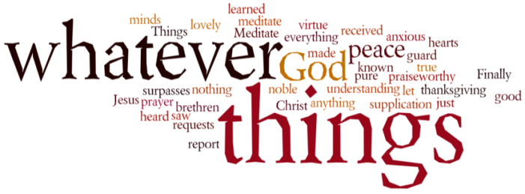
THINK ON THESE THINGS….. (our contributor this morning is Martin Osman)
Reading: Matthew 6: 31 – 34
³¹ So do not worry, saying, ‘What shall we eat?’ or ‘What shall we drink?’ or ‘What shall we wear?’ ³² For the pagans run after all these things, and your heavenly Father knows that you need them. ³³ But seek first his kingdom and his righteousness, and all these things will be given to you as well. ³⁴ Therefore do not worry about tomorrow, for tomorrow will worry about itself. Each day has enough trouble of its own.
Reflection:
I am by nature a worrier. My mother often used to tell me “if you haven’t got something to worry about you’re not happy.”
Worry is on many people’s minds at the moment and as we hopefully begin to see the light at the end of the Covid 19 tunnel many will be worried about the things Jesus talks about in this passage, especially those facing unemployment and that will surely include some Christians too.
It’s natural to want to pursue security in material things but Jesus tells us to seek first his kingdom and leave the rest to him.
He knows we need food and clothes but he tells us not to worry about them, the point being our heavenly Father is well aware we need them.
So we can be released from such stresses and give our attention to other things.
But that isn’t an excuse for lying back and doing nothing. To get that job we may be praying for won’t happen unless we submit the CV and go for the interview, we have to play our part too.
God has never ever abandoned his people throughout history either in the past or the present and he won’t do it as we face the future either.
When I left the railway in 2010 I was amazed how often this passage cropped up in sermons or daily Bible reading and yes, I worried about these things we are told not to worry about. But as Roger Manning always used to say when I spoke to him about it “he ain’t let you strave yet, has he?”
Breath-Prayer for Today: Father thank you that you proved for our needs, help us to be content in that assurance in these days in the days to come.

