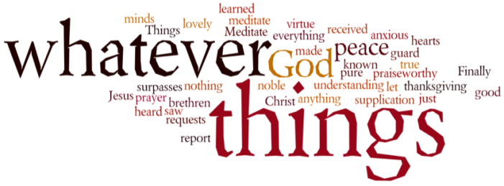
THINK ON THESE THINGS….. (our contributor this morning is Tony Wilson)
Readings: Meanwhile these three remain: faith, hope, and love; and the greatest of these is love. (1 Corinthians 13:13.)
God is our hope and strength: a very present help in trouble. (Psalm 46:1)
Reflection
Over the years I've heard many sermons on faith and love, but very few on hope. The present time is one where not just hope, but Christian hope, which is much more than ordinary hope, is needed. Ordinary hope is only cheerful optimism. It's the idea that it will probably work out OK in the end.
In difficult times it seems a bit like an inappropriate joke. In contrast Christian hope tells us that even in the grimmest of times, we have a future. Even if that future contains trouble, we know that it will be a good future. Such hope is to expect a good future which rests on the promise of God. It's a confident waiting on a future given by God, and is so much more than any human hope. That's something we can see as a recurring theme in the Bible.
For instance, look at the Parable of the Good Samaritan (Luke 10:25-37). It's usually used to illustrate Christian love. However, the Samaritan also showed hope for the wounded man he'd found. It was a hope, a certainty, that the injured man would overcome the trouble that was his immediate future. You can't love your neighbours without also having hope for them too.
Breath-Prayer for Today: Almighty God, in whom is all our hope, we ask that we may face whatever the future bolds in store for us calm and unafraid, always confident that nothing can part us from your love. Amen.

