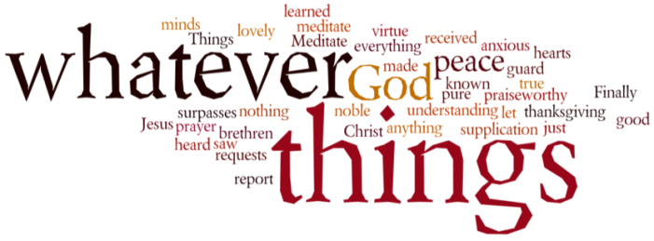
THINK ON THESE THINGS…..
Reading: Exodus 3:16 - 20
¹⁶ “Go, assemble the elders of Israel and say to them, ‘The Lord, the God of your fathers—the God of Abraham, Isaac and Jacob—appeared to me and said: I have watched over you and have seen what has been done to you in Egypt. ¹⁷ And I have promised to bring you up out of your misery in Egypt into the land of the Canaanites, Hittites, Amorites, Perizzites, Hivites and Jebusites—a land flowing with milk and honey.’
¹⁸ “The elders of Israel will listen to you. Then you and the elders are to go to the king of Egypt and say to him, ‘The Lord, the God of the Hebrews, has met with us. Let us take a three-day journey into the wilderness to offer sacrifices to the Lord our God.’ ¹⁹ But I know that the king of Egypt will not let you go unless a mighty hand compels him. ²⁰ So I will stretch out my hand and strike the Egyptians with all the wonders that I will perform among them. After that, he will let you go.
Reflection:
Moses was certainly surprised by God’s appearance in the burning bush, but he must have been amazed by what God called him to do – to become a liberator for His people. In Egypt, the events that would bring the Israelites their freedom were already in motion, but they had no clue that God was even aware of their suffering.
Moses must have felt that what God wanted to achieve through him was an impossible dream. The idea that the Israelites would be freed, must have sounded completely insane. Yet, somehow Moses must have believed, at least a little, and so he started on a journey that would take the rest of his life, that would bring him great frustration and suffering, but that would free a nation and show the world that God is always at work bringing life and justice.
The resurrection life of God is always like this. Long before we know that God is even aware of our struggles, our Lord is already at work to bring light into the darkness and life out of death.
Sometimes we cannot begin to conceive of how God can restore us, and it feels absurd to hold on to hope, particularly in the times we are living through right now. But, as resurrection people, we know that all is never lost. We know that God often seeks to use us to bring life to others in whatever small way we can. We may not be called to be great liberators like Moses, but we can set one or two other people free through our loving acceptance, support, and encouragement, and our willingness to help wherever we can.
Breath-Prayer for Today: Loving Lord, your life is always at work in and through me, even when I don’t see it.

