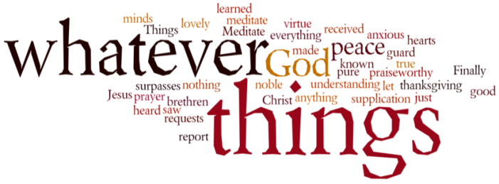
THINK ON THESE THINGS…..
Reading: Hebrews 13: 20, 21
Now may the God of peace, who through the blood of the eternal covenant brought back from the dead our Lord Jesus, that great Shepherd of the sheep, ²¹ equip you with everything good for doing his will, and may he work in us what is pleasing to him, through Jesus Christ, to whom be glory for ever and ever. Amen.
Reflection: The book of Hebrews is often seen as a rather complicated book, that doesn’t often make an appearance in daily readings. The writer does a great job of describing the work of Jesus through the language of the Israelite sacrificial system. He speaks of Jesus as both the great high priest and the sacrifice. In doing this work, Jesus reveals God’s availability to us, and our belonging in God’s covenant family.
But, in his final comments, the writer draws on a different description – the great shepherd of the sheep, the theme for last Sunday’s worship. When God raised Jesus from the dead, our Lord assured us that not even death could break the covenant he had made with us. But, God also called us to participate in his saving, restoring work.
That’s why the writer prays that God would equip the believers with everything they need for doing his will, and give them the power to please God - which, as we know from the Gospels, is all about loving God and our neighbour.
As shepherd, then, Jesus has protected us from death, has ensured that nothing can separate us from God’s love, and has shown us how to live lives that please God. Everything Jesus did was not for his own sake, but for ours. What an amazing shepherd!
We need that assurance right now don’t we? To know deep down that as we struggle through these difficult times, our Shepherd is there to guide, comfort and strengthen us, and to encourage us to keep trusting him. Remember these words – never doubt in the tough times, what God has revealed to you in the good times!
Breath-Prayer for Today: Thank you, Jesus, my Shepherd, for all the gifts you have given me, and for the daily assurance of your love.

